**21.HOSPITAL MANAGEMENT SYSTEM**

**USECASE DIAGRAM:**

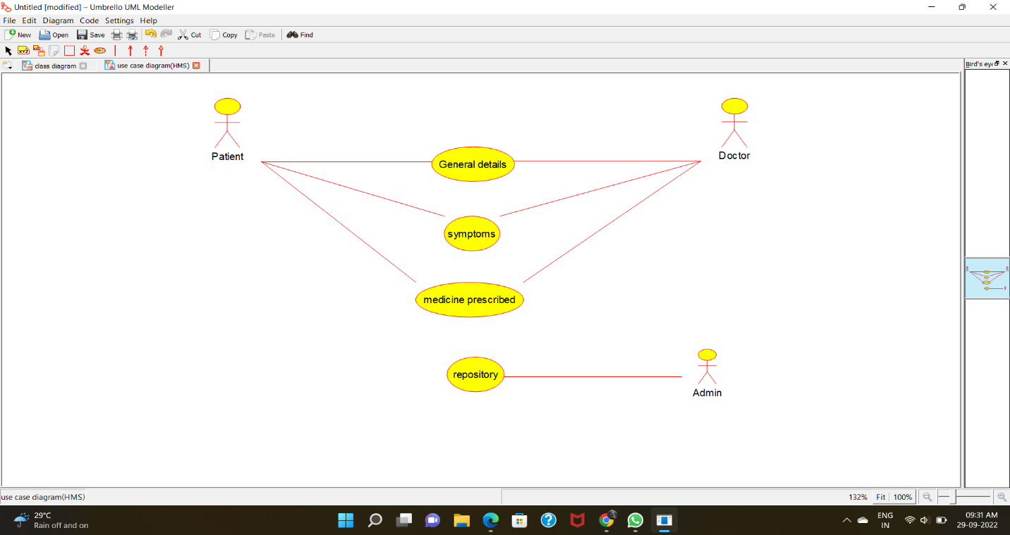

**CLASS DIAGRAM:**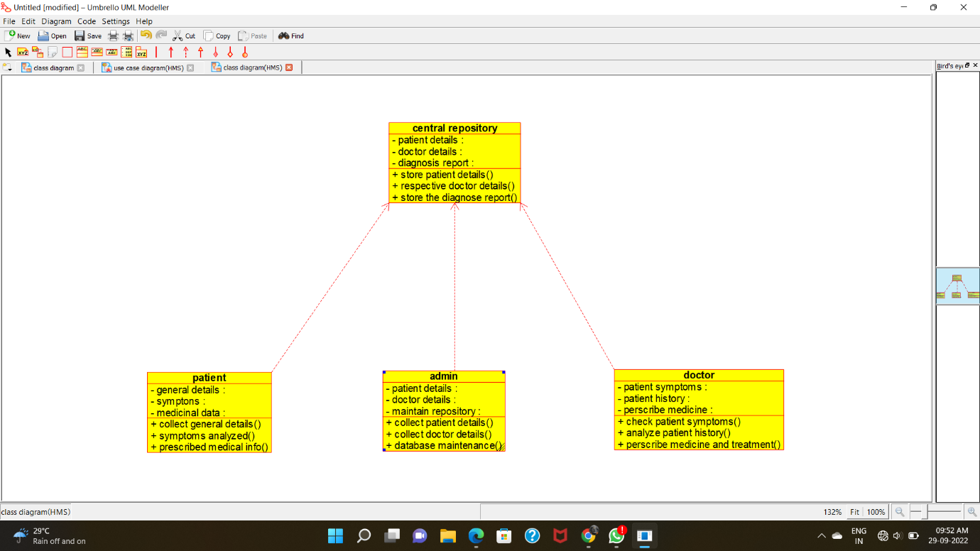

**ACTIVITY DIAGRAM:**

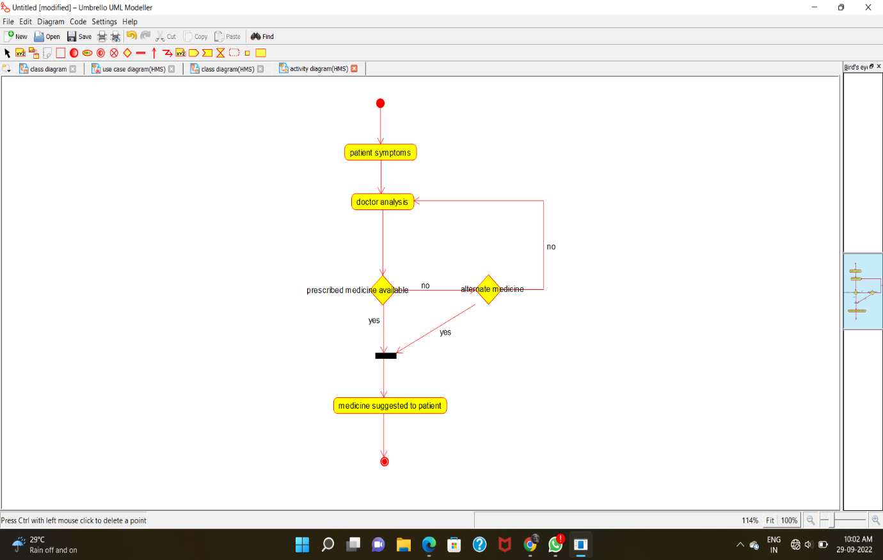

**SEQUENCE DIAGRAM:** 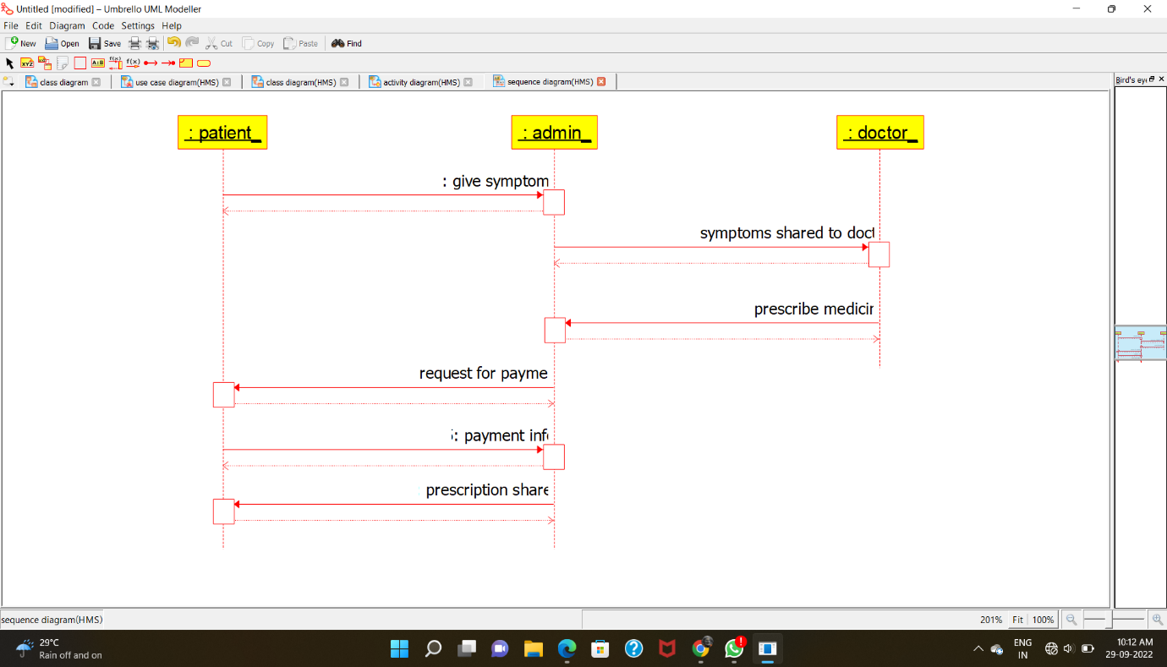

**COLLABRATION DIAGRAM:**

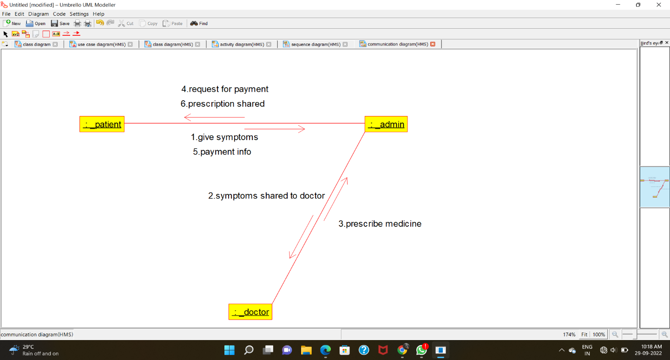

**STATE-CHART DIAGRAM:**

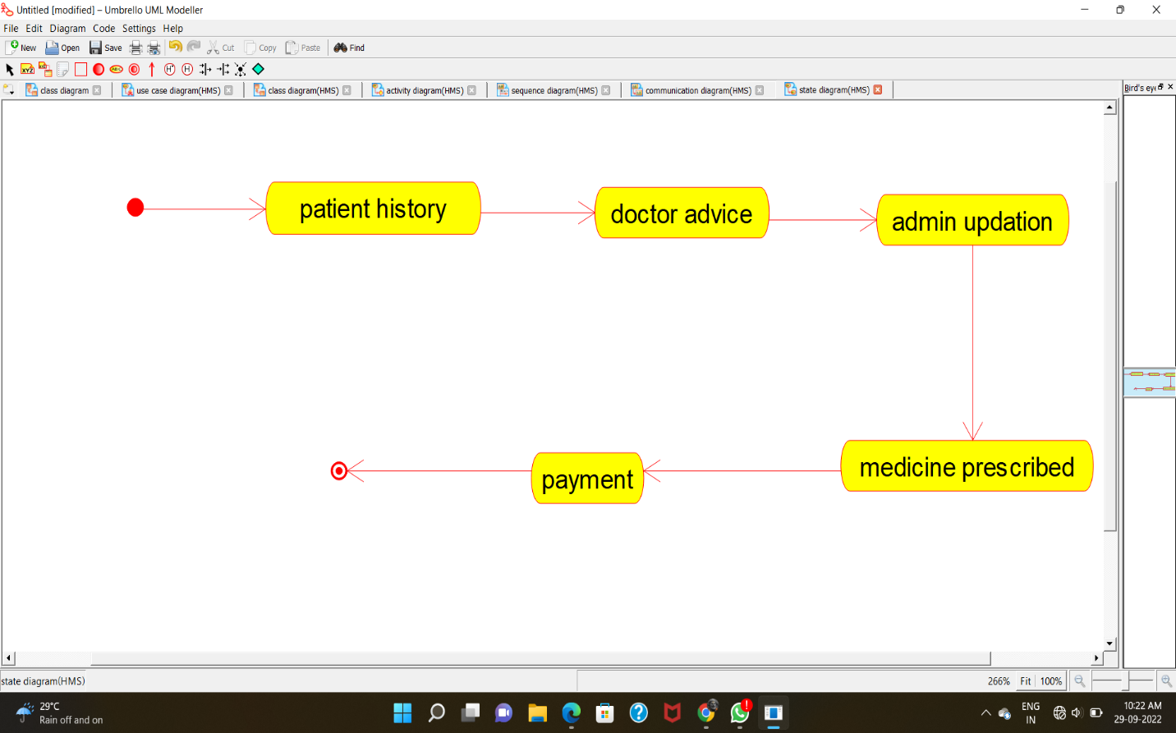

**COMPONENT DIAGRAM:**

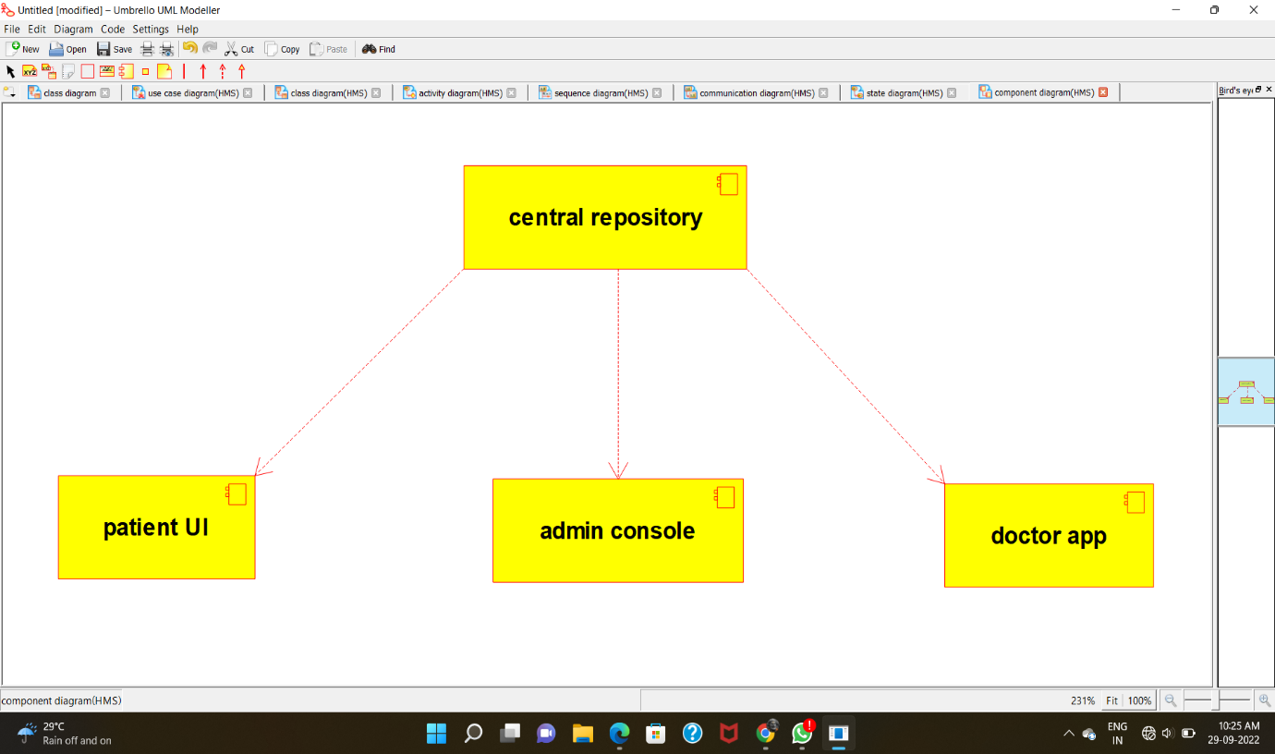

**DEPLOYMENT DIAGRAM:**

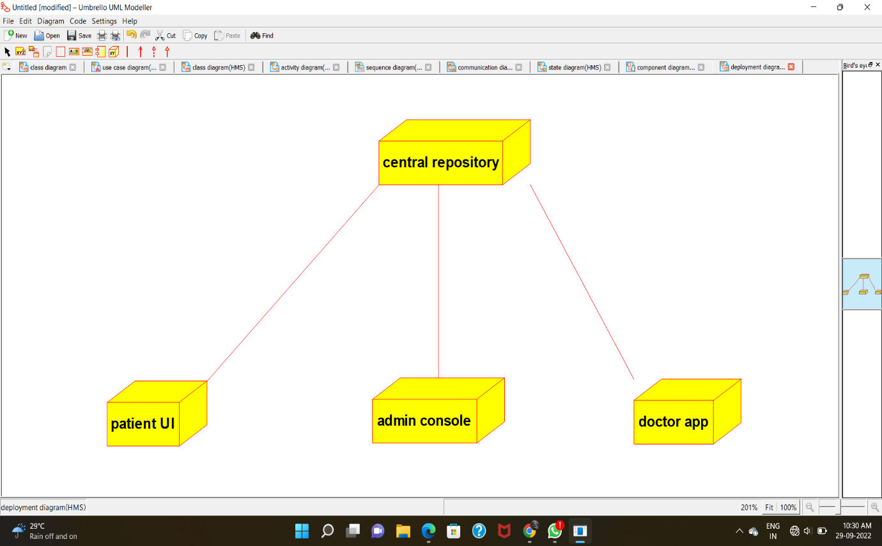

**PROGRAM CODE:**

**CENTRAL REPOSITORY:**

**/\*\***

**\* Class central_repository**

**\*/**

**public class central_repository {**

**//**

**// Fields**

**//**

**private void patient_details;**

**private void doctor_details;**

**private void diagnosis_report;**

**//**

**// Constructors**

**//**

**public central_repository () { };**

**//**

**// Methods**

**//**

**//**

**// Accessor methods**

**//**

**/\*\***

**\* Set the value of patient_details**

**\* @param newVar the new value of patient_details**

**\*/**

**private void setPatient_details (void newVar) {**

**patient_details = newVar;**

**}**

**/\*\***

**\* Get the value of patient_details**

**\* @return the value of patient_details**

**\*/**

**private void getPatient_details () {**

**return patient_details;**

**}**

**/\*\***

**\* Set the value of doctor_details**

**\* @param newVar the new value of doctor_details**

**\*/**

**private void setDoctor_details (void newVar) {**

**doctor_details = newVar;**

**}**

**/\*\***

**\* Get the value of doctor_details**

**\* @return the value of doctor_details**

**\*/**

**private void getDoctor_details () {**

**return doctor_details;**

**}**

**/\*\***

**\* Set the value of diagnosis_report**

**\* @param newVar the new value of diagnosis_report**

**\*/**

**private void setDiagnosis_report (void newVar) {**

**diagnosis_report = newVar;**

**}**

**/\*\***

**\* Get the value of diagnosis_report**

**\* @return the value of diagnosis_report**

**\*/**

**private void getDiagnosis_report () {**

**return diagnosis_report;**

**}**

**//**

**// Other methods**

**//**

**/\*\***

**\*/**

**public void store_patient_details()**

**{**

**}**

**/\*\***

**\*/**

**public void respective_doctor_details()**

**{**

**}**

**/\*\***

**\*/**

**public void store_the_diagnose_report()**

**{**

**}**

**}**

**PATIENT:**

**/\*\***

**\* Class patient**

**\*/**

**public class patient {**

**//**

**// Fields**

**//**

**private void general_details;**

**private void symptons;**

**private void medicinal_data;**

**//**

**// Constructors**

**//**

**public patient () { };**

**//**

**// Methods**

**//**

**//**

**// Accessor methods**

**//**

**/\*\***

**\* Set the value of general_details**

**\* @param newVar the new value of general_details**

**\*/**

**private void setGeneral_details (void newVar) {**

**general_details = newVar;**

**}**

**/\*\***

**\* Get the value of general_details**

**\* @return the value of general_details**

**\*/**

**private void getGeneral_details () {**

**return general_details;**

**}**

**/\*\***

**\* Set the value of symptons**

**\* @param newVar the new value of symptons**

**\*/**

**private void setSymptons (void newVar) {**

**symptons = newVar;**

**}**

**/\*\***

**\* Get the value of symptons**

**\* @return the value of symptons**

**\*/**

**private void getSymptons () {**

**return symptons;**

**}**

**/\*\***

**\* Set the value of medicinal_data**

**\* @param newVar the new value of medicinal_data**

**\*/**

**private void setMedicinal_data (void newVar) {**

**medicinal_data = newVar;**

**}**

**/\*\***

**\* Get the value of medicinal_data**

**\* @return the value of medicinal_data**

**\*/**

**private void getMedicinal_data () {**

**return medicinal_data;**

**}**

**//**

**// Other methods**

**//**

**/\*\***

**\*/**

**public void collect_general_details()**

**{**

**}**

**/\*\***

**\*/**

**public void symptoms_analyzed()**

**{**

**}**

**/\*\***

**\*/**

**public void prescribed_medical_info()**

**{**

**}**

**}**

**ADMIN:**

**/\*\***

**\* Class admin**

**\*/**

**public class admin {**

**//**

**// Fields**

**//**

**private void patient_details;**

**private void doctor_details;**

**private void maintain_repository;**

**//**

**// Constructors**

**//**

**public admin () { };**

**//**

**// Methods**

**//**

**//**

**// Accessor methods**

**//**

**/\*\***

**\* Set the value of patient_details**

**\* @param newVar the new value of patient_details**

**\*/**

**private void setPatient_details (void newVar) {**

**patient_details = newVar;**

**}**

**/\*\***

**\* Get the value of patient_details**

**\* @return the value of patient_details**

**\*/**

**private void getPatient_details () {**

**return patient_details;**

**}**

**/\*\***

**\* Set the value of doctor_details**

**\* @param newVar the new value of doctor_details**

**\*/**

**private void setDoctor_details (void newVar) {**

**doctor_details = newVar;**

**}**

**/\*\***

**\* Get the value of doctor_details**

**\* @return the value of doctor_details**

**\*/**

**private void getDoctor_details () {**

**return doctor_details;**

**}**

**/\*\***

**\* Set the value of maintain_repository**

**\* @param newVar the new value of maintain_repository**

**\*/**

**private void setMaintain_repository (void newVar) {**

**maintain_repository = newVar;**

**}**

**/\*\***

**\* Get the value of maintain_repository**

**\* @return the value of maintain_repository**

**\*/**

**private void getMaintain_repository () {**

**return maintain_repository;**

**}**

**//**

**// Other methods**

**//**

**/\*\***

**\*/**

**public void collect_patient_details()**

**{**

**}**

**/\*\***

**\*/**

**public void collect_doctor_details()**

**{**

**}**

**/\*\***

**\*/**

**public void database_maintenance()**

**{**

**}**

**}**

**DOCTOR:**

**/\*\***

**\* Class doctor**

**\*/**

**public class doctor {**

**//**

**// Fields**

**//**

**private void patient_symptoms;**

**private void patient_history;**

**private void perscribe_medicine;**

**//**

**// Constructors**

**//**

**public doctor () { };**

**//**

**// Methods**

**//**

**//**

**// Accessor methods**

**//**

**/\*\***

**\* Set the value of patient_symptoms**

**\* @param newVar the new value of patient_symptoms**

**\*/**

**private void setPatient_symptoms (void newVar) {**

**patient_symptoms = newVar;**

**}**

**/\*\***

**\* Get the value of patient_symptoms**

**\* @return the value of patient_symptoms**

**\*/**

**private void getPatient_symptoms () {**

**return patient_symptoms;**

**}**

**/\*\***

**\* Set the value of patient_history**

**\* @param newVar the new value of patient_history**

**\*/**

**private void setPatient_history (void newVar) {**

**patient_history = newVar;**

**}**

**/\*\***

**\* Get the value of patient_history**

**\* @return the value of patient_history**

**\*/**

**private void getPatient_history () {**

**return patient_history;**

**}**

**/\*\***

**\* Set the value of perscribe_medicine**

**\* @param newVar the new value of perscribe_medicine**

**\*/**

**private void setPerscribe_medicine (void newVar) {**

**perscribe_medicine = newVar;**

**}**

**/\*\***

**\* Get the value of perscribe_medicine**

**\* @return the value of perscribe_medicine**

**\*/**

**private void getPerscribe_medicine () {**

**return perscribe_medicine;**

**}**

**//**

**// Other methods**

**//**

**/\*\***

**\*/**

**public void check_patient_symptoms()**

**{**

**}**

**/\*\***

**\*/**

**public void analyze_patient_history()**

**{**

**}**

**/\*\***

**\*/**

**public void perscribe_medicine_and_treatment()**

**{**

**}**

**}**